Erasmus+ Support:

Licence Management System

for Beneficiaries

User Guide 6.0

Date | 18/09/2015
Version | 6.0
Author | Service Provider
Public | Beneficiary Institutions/Organisations

Table of Contents

Introduction 2
1. Access the OLS and log into the back-end 2
2. Structure of Erasmus+ OLS 2
3. Using the Erasmus+ OLS back-end features 2
3.1 How to allocate assessment licences to participants 2
3.2 How to modify/cancel an invitation and re-invite participants 2
3.3 How to allocate course licences to participants 2
3.3.1 Important information for Higher Education Institutions: automated allocation of course licences 2
3.3.2 OLS language course in the local language of the country 2
3.3.3 Manual allocation of course licences 2
3.3.4 Select the language of the course 2
3.4 How to monitor the licences used by your participants 2
3.4.1 How to resend an assessment invitation to a participant 2
3.4.2 How to delete an assessment invitation sent to a participant 2
3.5 How to monitor the expired projects 2
3.6 How to monitor the expired licences 2
3.6.1 How to reallocate a language assessment to a participant whose licence has expired 2
3.6.2 How to reallocate a language course to a participant whose licence has expired 2
3.7 How to edit your profile and create additional users 2
3.7.1 How to edit your profile 2
3.7.2 How to receive a notification each time a mobility participant has completed the 1st language assessment 2
3.7.3 How to create additional users (aliases) 2
3.7.4 How to delete additional users (aliases) 2
3.7.5 How to add or delete additional email addresses for future notifications 2
4. Helpdesk 2

Introduction

This user guide explains how to use the Erasmus+ OLS licence management system (back-end) in your role as a Beneficiary (BEN).
You will learn:
- How to log into the Erasmus+ OLS back-end;
- How the back-end is structured;
- How to use each feature, namely:
  - Allocating assessment licences to Participants,
  - Allocating course licences to Participants,
  - Monitoring the assessment and course licences used by Participants.

1. Access the OLS and log into the back-end

To access the OLS go to the following URL: http://www.erasmusplusols.eu.
To access the login page, click the Login button in the upper right corner of your screen.
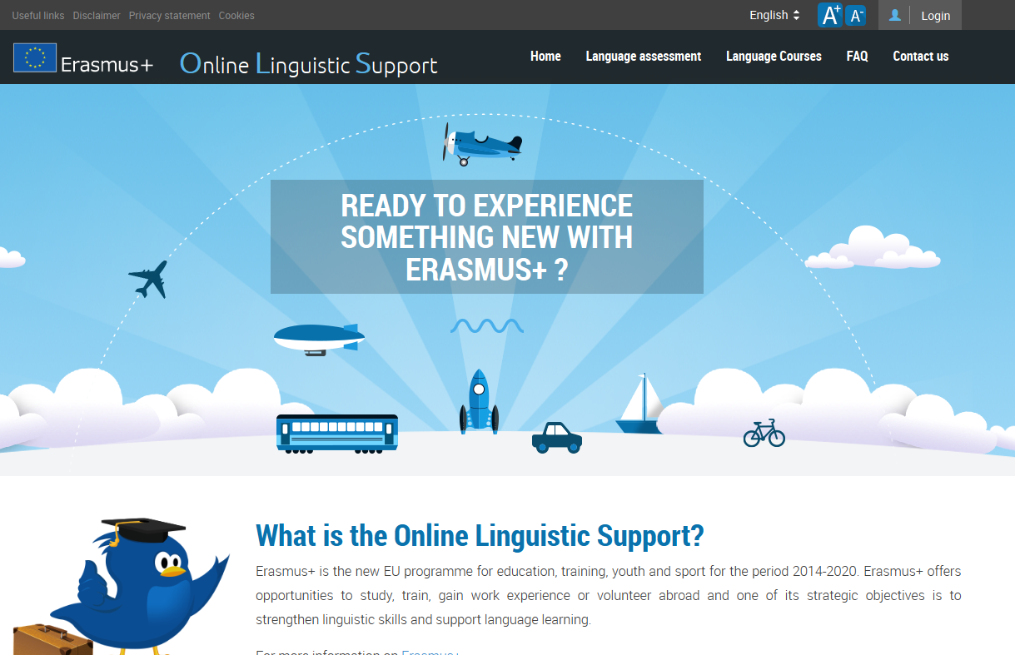

To log in, type in the Login and the Password you received by email.

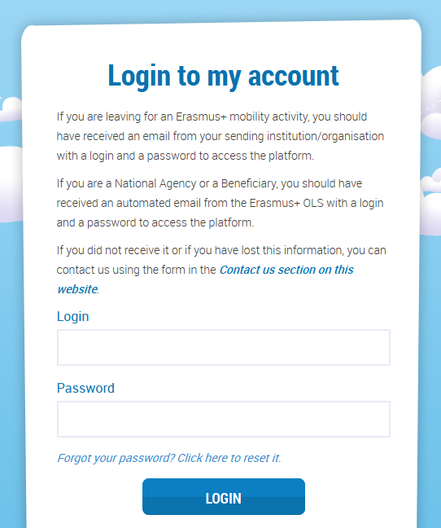

In case you encounter problems, you can contact the Helpdesk by clicking the Contact us button on the upper right hand corner of your screen.

2. Structure of Erasmus+ OLS

The homepage of Erasmus+ OLS appears after you log-in.
On the static toolbar on the upper part of your screen you have 4 buttons:
- Home button () – click on this button to go to the OLS back-end homepage.
- Profile button (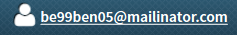) – click on this button to go to your BEN user profile page.
- Report a Problem – click on the button to contact the Helpdesk for any technical problem.
- ESC () – click on the button to close your session.
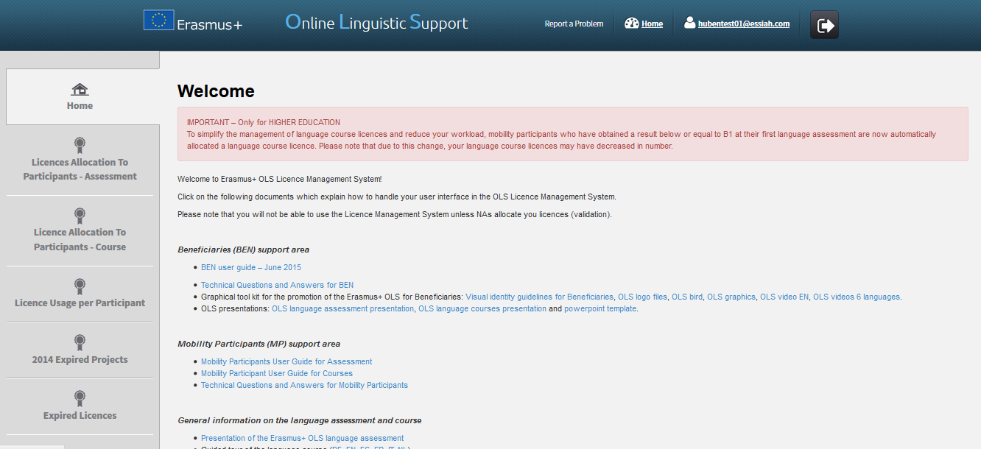

On this page you find important information regarding updates, forthcoming features of the OLS and system alerts, as well as OLS communication materials facilitating your daily work.

Four tabs are available in the menu on the left hand side of your screen:
- Home (tab 1)
- Licence Allocation to Participants - Assessment (tab 2)
- Licence Allocation to Participants - Course (tab 3)
- Licence Usage per Participant (tab 4)
- Expired 2014 Projects (tab 5)
- Expired Licences (tab 6)

Click on any tab to navigate between Home, Licence Allocation to Participants – Assessment, Licence Allocation to Participants - Course and License Usage per Participant, 2014 Projects and Expired Licences.

3. Using the Erasmus+ OLS back-end features

In this section the main functionalities of the Erasmus+ OLS back-end are explained:
- 3.1 Allocating assessment licences to participants,
- 3.2 Modifying or cancelling an invitation and re-inviting participants,
- 3.3 Allocating course licences to participants,
- 3.4 Monitoring the licences usage of the participants,
- 3.5 Monitoring expired projects,
- 3.6 Monitoring expired licences,
- 3.7 Editing your profile and creating additional users.

3.1 How to allocate assessment licences to participants

The process of allocating licences occurs at different levels (i.e. DG EAC / NA / BEN) – for more information on the process please consult your National Agency.
To allocate assessment licences to your participants, please follow these step-by-step instructions.

To access the section "Licence Allocation to Participants – Assessment", from your Home screen, click on the 2nd tab (Licence Allocation to Participants – Assessment).
You are now accessing the Licence Allocation to Participants – Assessment page.
If your institution/organisation is part of several projects, you can find several tabs on the top of the page. By navigating through those tabs, you can access the corresponding “Licence Allocation to Participants – Assessment” page related to each of your projects.
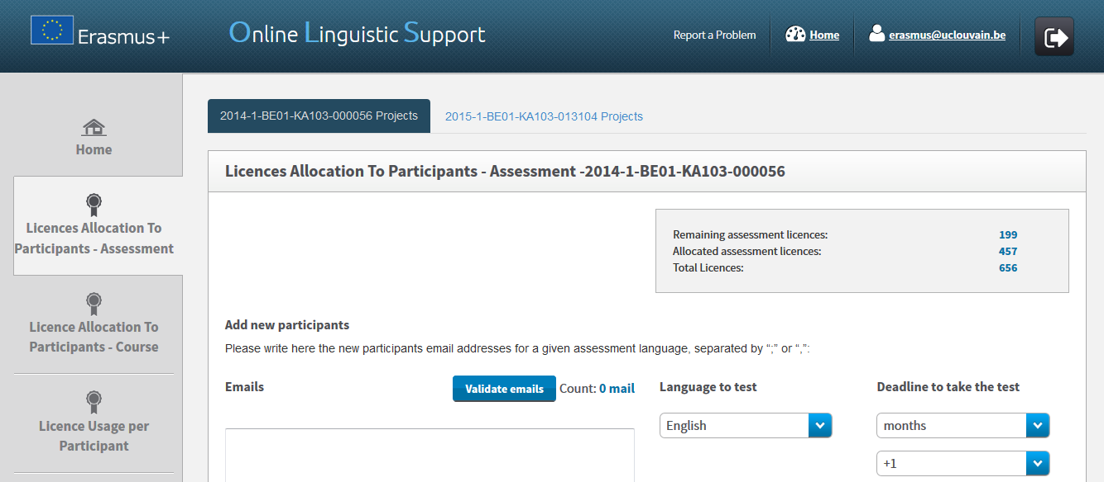

In the upper right part of the screen, a summary box also shows information on:
- Your BEN’s remaining number of assessment licences, i.e. the number of licences currently available for Participants allocation;
- Your BEN’s number of allocated assessment licences, i.e. the number of assessment invitations already sent to your participants;
- The total number of assessment licences granted to your BEN by your National Agency (NA).
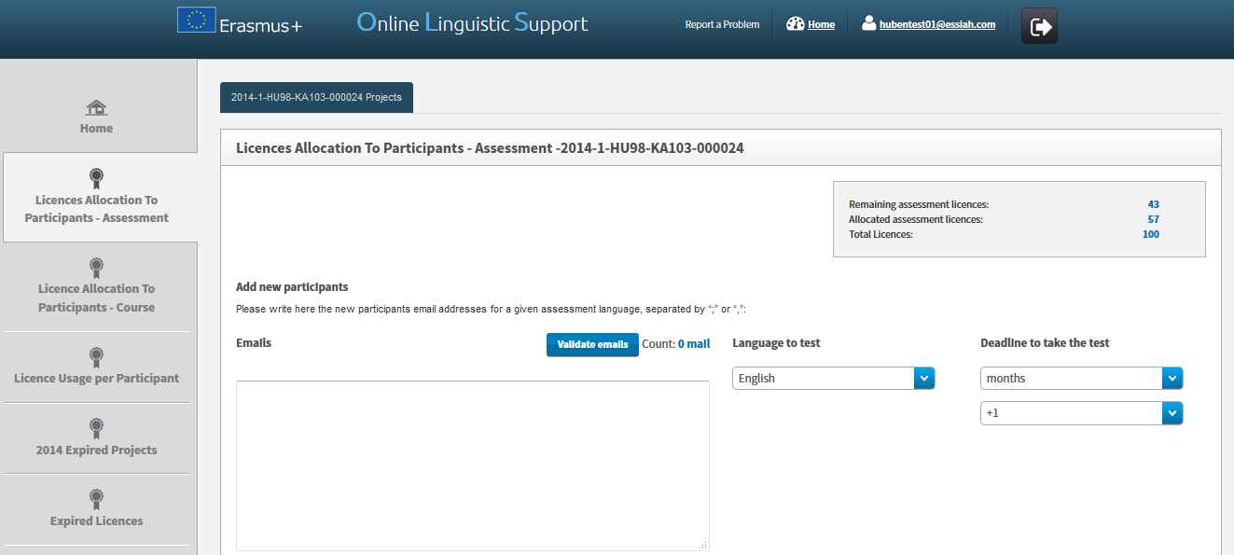
To allocate assessment licences to the selected project participants, please indicate, in the appropriate box, all their email addresses, separated by “;” or “,”. N.B.: you are requested to introduce together the email addresses of all participants who will be tested in the same language (for example, all participants taking their assessment in French). If you have groups of participants to be tested in different languages, repeat the following steps, language per language.

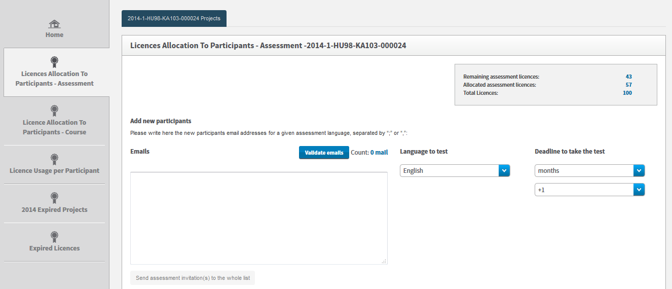

Before being able to move forward, you are requested to validate the email address list by clicking on Validate emails. A message appears when emails are successfully validated. Then, make sure the count of email addresses is correctly shown next to the Validate emails button.
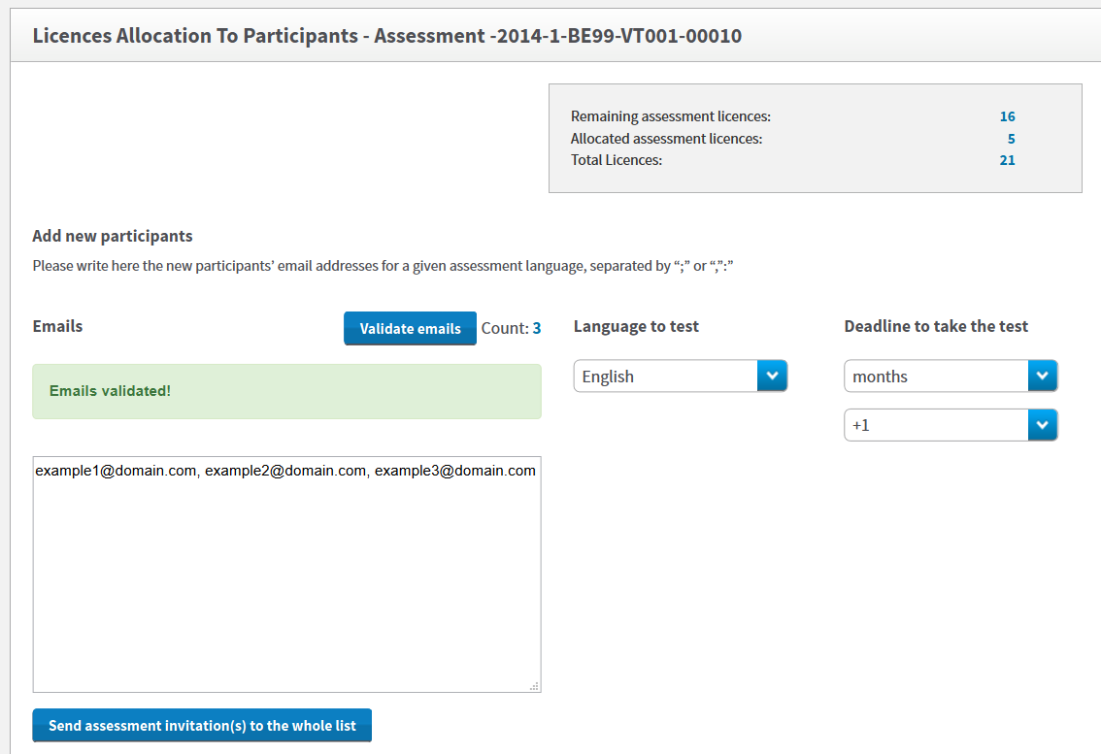

You are now requested to select the language to be tested in the highlighted Language to test scroll-down menu. The language tested corresponds to the language the participants will use to study, work or volunteer abroad and cannot be changed afterwards.

You are also requested to select a Deadline to take the test. To do so, select the number of days or months given to the participants to take the test. Please note that the deadline should be set before the participant’s departure date, especially for HE participants since the OLS assessment is a pre-requisite for mobility.

Once the email list is validated, the language to test and the deadline to take the test are selected, the Send assessment invitation(s) to the whole list becomes active. Review all information before clicking on this button to send assessment invitations to all validated email addresses.

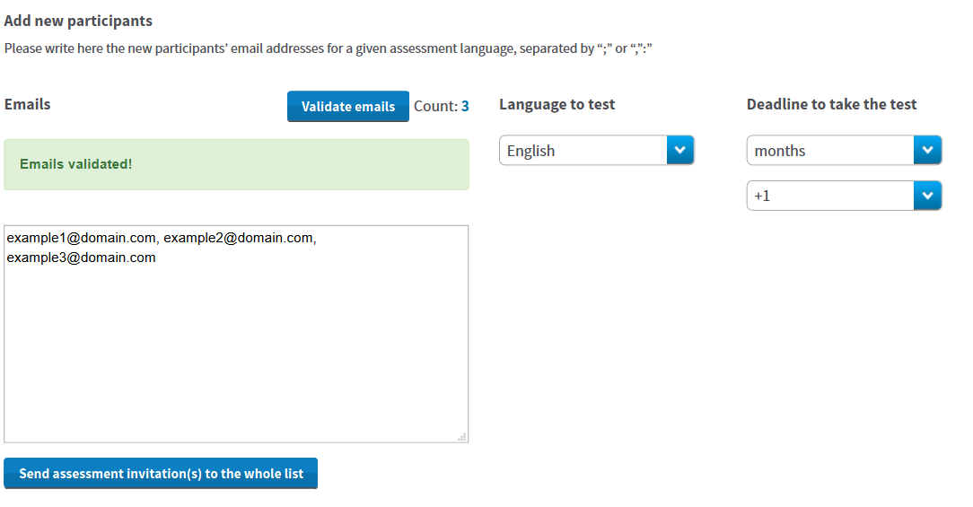

Invitations are then automatically sent to the participants and a message pops-up confirming the invitations were successfully sent. The participants also receive an email containing their personal login and password needed to access the Erasmus+ OLS language assessment.

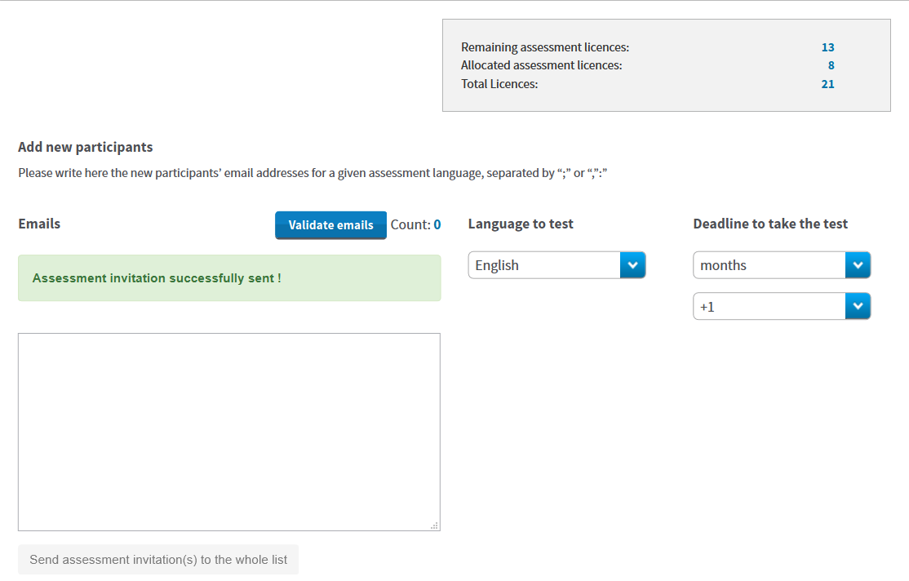

If your participants have to be tested in several languages, repeat the above instructions for each group of participants/languages.
Should you wish to receive a notification once a participant has completed the first language assessment, please click on your profile.

In your profile, you have the possibility to tick the "I want to receive a notification by email each time a participant has finished the first assessment" box. Further information is provided under point 3.7.

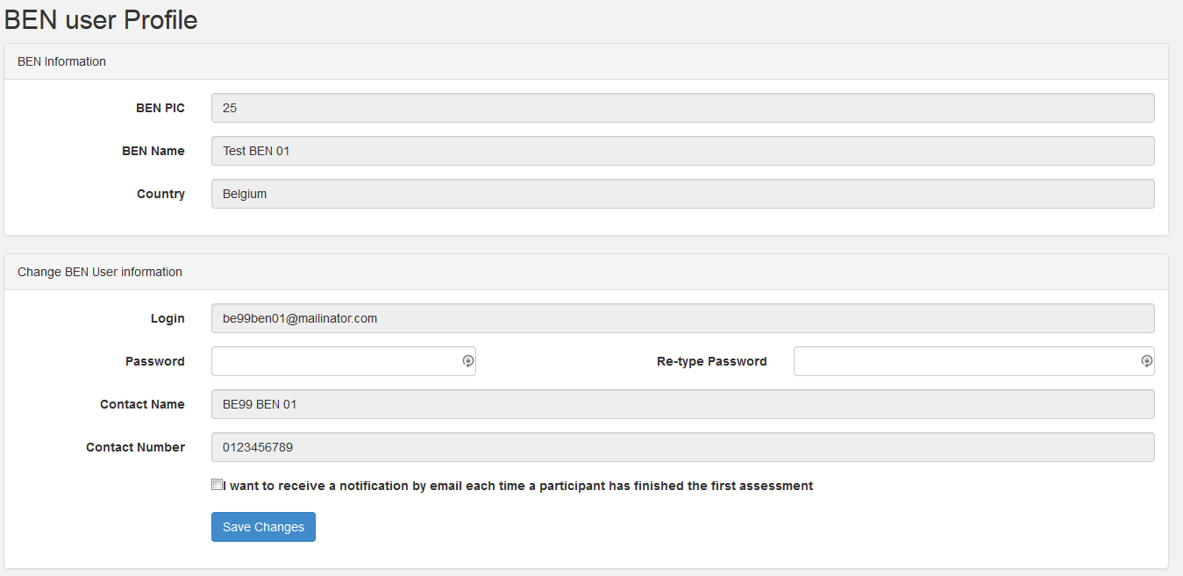

If you tick this box, you will receive an email notification whenever a participant has completed the first language assessment. These notifications are not sent instantly, but rather once every hour.
Please note, this notification is sent to the main email address, as well as to any aliases and additional email addresses linked to the profile.
When participants don’t take the assessment within the deadline, their access to OLS is deactivated and the licence automatically returns to your remaining assessment licences. For instructions on how to re-invite a mobility participant for the 1st language assessment, see point 3.4.1.

3.2 How to modify/cancel an invitation and re-invite participants

When invitations are sent, they cannot be edited or modified. If you need to modify or cancel an invitation, please follow these step-by-step instructions.
Licences can be cancelled provided that the participant(s) haven’t started the language assessment yet. Licences that have been cancelled automatically return in your remaining assessment licences.
To cancel the invitation(s), you need to enter the email address(es) of the participant(s) that need to be cancelled in the invitation box and click on “Validate emails”.
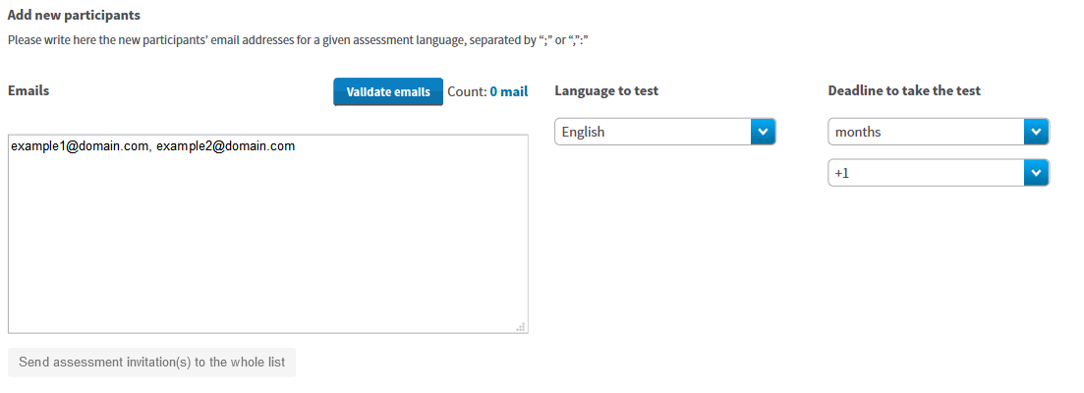
A pop-up message appears notifying that this/these email address(es) has/have already received a language assessment licence and asks you if you want to cancel the invitation.

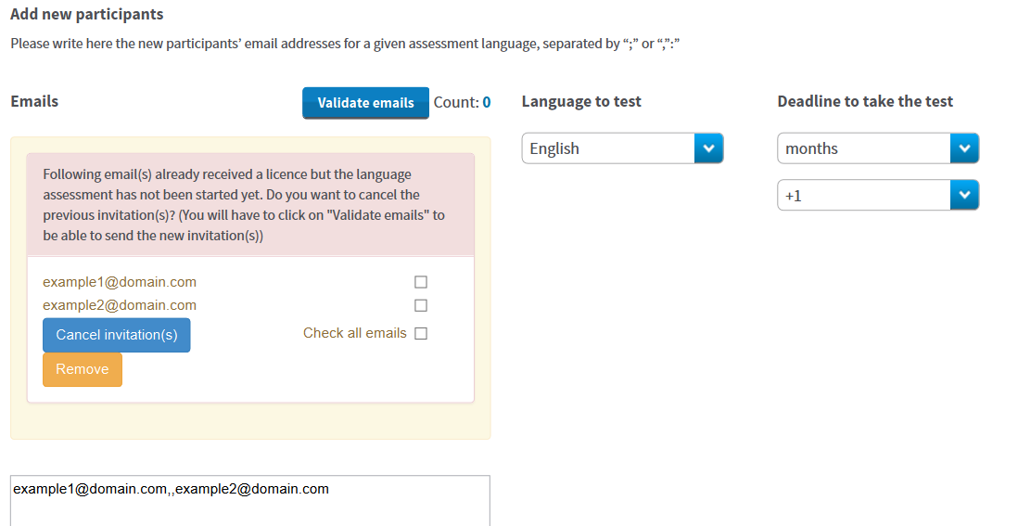

To cancel the invitation(s), click on the box next to the email address(es) to select the email addresses that need to be cancelled or click on “check all emails”. Click on “Cancel invitation(s)” in order to cancel the invitations you sent to the participant(s). The licences automatically return to your remaining licences.
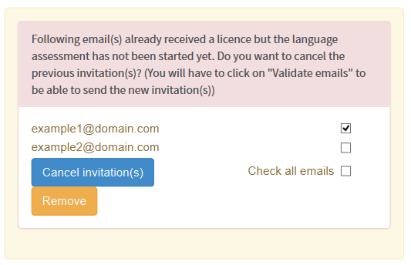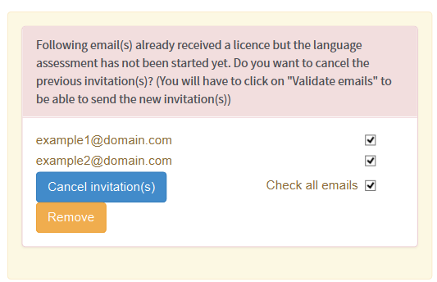

Once you have cancelled the invitation, the email address(es) concerned disappear from the pop-up and still appear in the invitation box.
To send a new invitation to this/these email address(es), click on Validate Emails and follow the steps explained previously at section 3.1 How to allocate assessment licences to participants.

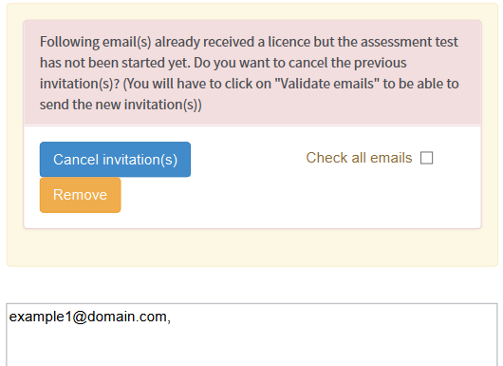

3.3 How to allocate course licences to participants

The process of allocating licences occurs at different levels (i.e. DG EAC / NA / BEN) – for more information on the process please consult your National Agency.

3.3.1 Important information for Higher Education Institutions: automated allocation of course licences

Automatic language course allocation
Higher education participants who have obtained a result between CEFR levels A1 and B1 in their first language assessment are automatically allocated a language course licence. As an HEI you do not need to take any further action in the OLS Licence Management System.
The language course allocated is in the mobility language chosen for the assessment.
Course licences are automatically deducted according to the total course licences allocated. Therefore, participants with a level of B1 or below do not appear in this section. You are able to find these participants in the 4th tab (Licence Usage per Participant).

3.3.2 OLS language course in the local language of the country

Mobility participants who have obtained a result between CEFR levels B2 and C2 in their first language assessment might be invited to follow a language course in the OLS Licence Management System. The language course can be in their main language of instruction/work, OR in the local language of the country, provided that the language is available in the OLS.
In the 3rd tab (Licence Allocation to Participants – Course) you can also see mobility participants who have obtained a between CEFR levels B2 and C2 at their first language assessment. You are able to manually select the language of the courses for these participants.

For the specific instructions see point 3.3.3.

3.3.3 Manual allocation of course licences

Manual allocation of course licences applies to Youth, VET and HE participants (for HE only CEFR level B2 – C2).
To allocate course licences to your participants, please follow these step-by-step instructions, here below.
To access the section "Licence Allocation to Participants - Course", from your Home screen, click on the 3rd tab (Licence Allocation to Participants - Course).

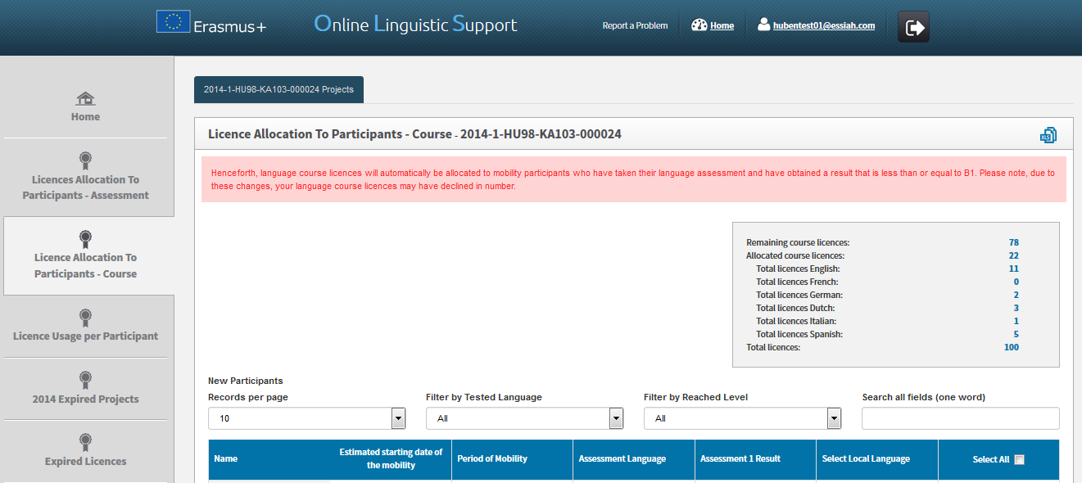

You are now accessing the Licence Allocation to Participants - Course page.
If your institution/organisation is part of several projects, you can find several tabs on the top of the page. By navigating through those tabs, you can access the corresponding “Licence Allocation to Participants - Course” page related to each of your projects.
Expired projects (projects having reached their contractual end date) continue to be shown as a separate tab, thus allowing you to continue allocating course licences to mobility participants who have not yet returned from their mobility. For more information on expired projects, please consult point 3.6.

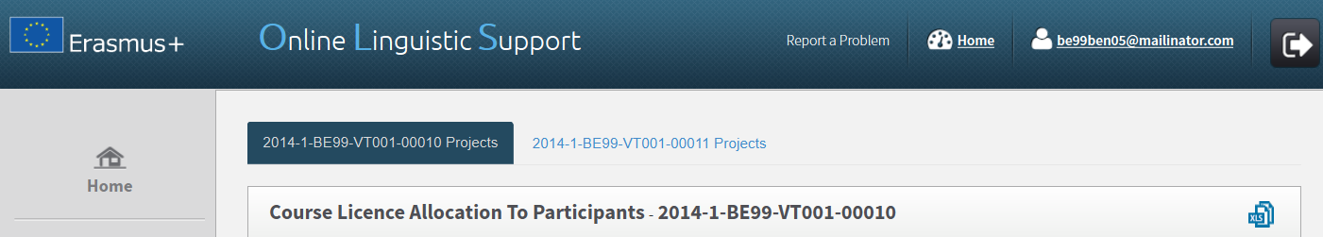

In the upper right part of the screen, a summary box also shows information on:
- Your BEN’s remaining number of course licences, i.e. the number of licences currently available for allocation to your Participants;
- Your BEN’s total number of allocated course licences, i.e. the number of licences already allocated to your participants;
- Your BEN’s number of allocated course licences, per language (German, English, Spanish, French, Italian and Dutch);
- The total number of course licences granted to your BEN by your National Agency (NA).

In the lower part of your screen you see the list of participants related to the selected project who:
- Received an assessment licence;
- Have completed the first assessment;
- NB: for HE participants, only those having obtained a result between CEFR levels B2 and C2 at their first language assessment;
- Have not returned from their Erasmus+ mobility yet.

For each of your participants the following information is available:
- Name
- Estimated Starting Date of the Mobility
- Period of Mobility
- Assessment Language, i.e. the mobility language allocated to the participant for his/her language assessment
- First Language Assessment Result
- Select Local Language

You can also sort the information by alphabetical or numerical order by clicking on a column title.

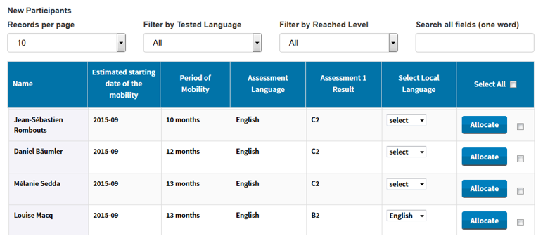

On your screen several functions are available:
- : by clicking on this button you can export all information on Licence Allocation to Participants - Course in an Excel file;
- New Participants Records per page scroll-down menu: by clicking on this button you can change the number of Licence Allocation to Participants - Course records that are shown per page;
- Filter by Tested Language scroll-down menu: by clicking on this button you can filter the displayed entries, based on the language tested during the 1st assessment;
- Filter by Reached Level scroll-down menu: by clicking on this button you can filter the displayed entries, based on the level achieved on the 1st assessment;
- Search all fields field: by using this field you can search participants by any data (one word only);
Previous and Next buttons: by clicking on those buttons you can navigate in the different pages of the Licence Allocation to Participants – Course table.
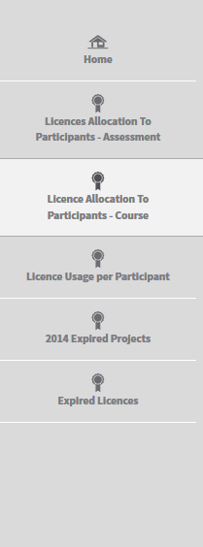
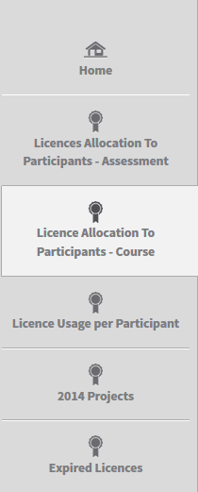
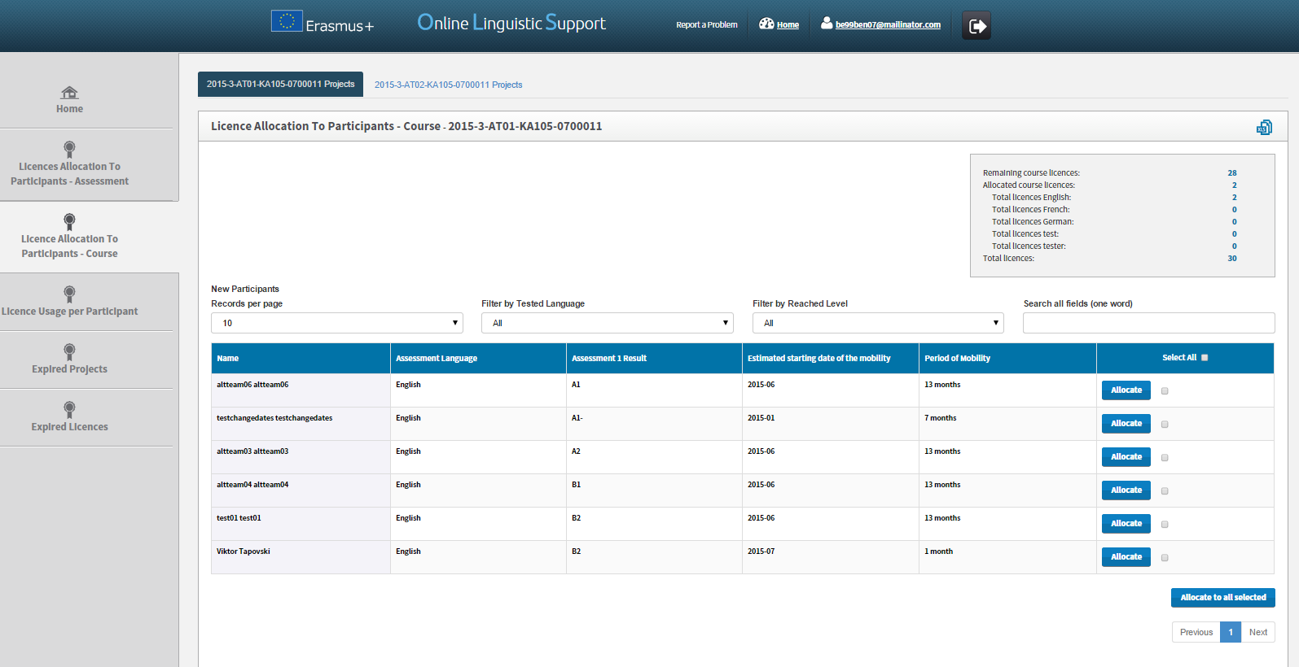
To allocate a course licence to a participant click on Allocate on the right-hand side of the participant’s row. A message then appears confirming that the course licence has been successfully allocated.

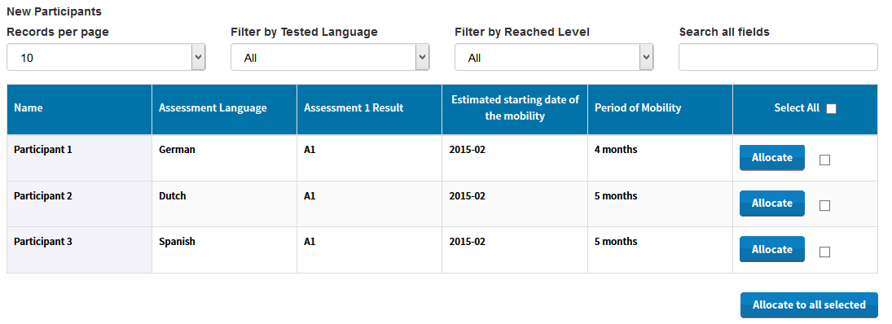
When a participant has been allocated a course licence, the related row disappears from the Licence Allocation to Participants – Course table. The participants also receive a link to access the Erasmus+ OLS language courses by email.
To allocate course licences to several participants, tick the boxes related to those participants in the cells on the far right of the mobility participants’ rows. Then click on the Allocate to all selected button.

If you wish to allocate licences to all participants in the list, you can select them all by clicking on the Select all button in the column title.
When participants do not connect to the language courses within 30 days after receiving the invitation, their access is deactivated and the licence automatically returns to your remaining language course licences.

3.3.4 Select the language of the course

You may invite participants listed in this screen – those who have obtained a result between CEFR levels B2 and C2 in their first language assessment – to follow a language course in their main language of instruction/work, OR in the local language of the country, provided that the language is available in the OLS.
In the column “Select Local Language”, a dropdown box gives you the option to select the course licence language that should be allocated. For participants who have obtained a result equal to C2, no language is selected by default. The mobility language (language assigned for the assessment) for all other levels is selected by default but this can be modified.
- If the mobility language (same language as the first language assessment) is selected, both assessments and the courses will be in the same language.

- If the “Select Local Language” (language of the country in which the mobility occurs) is modified, this means the participant will have the option to access a course in a language other than that of the first assessment. The participant, however, needs to take the second language assessment in the mobility language.

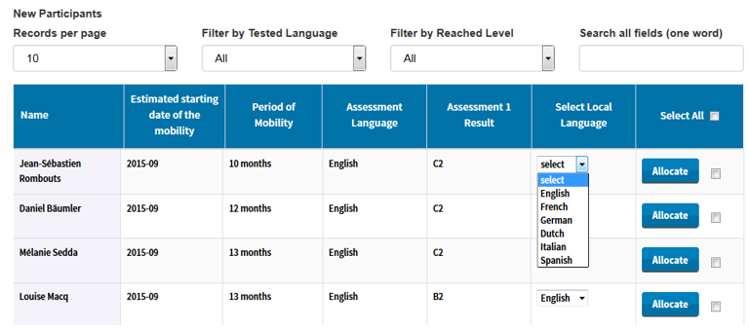

To allocate a course licence to a participant, first, select the language you want to assign him/her and then click on Allocate on the right-hand side of the participant’s row. A message then appears confirming that the course licence has been successfully allocated.

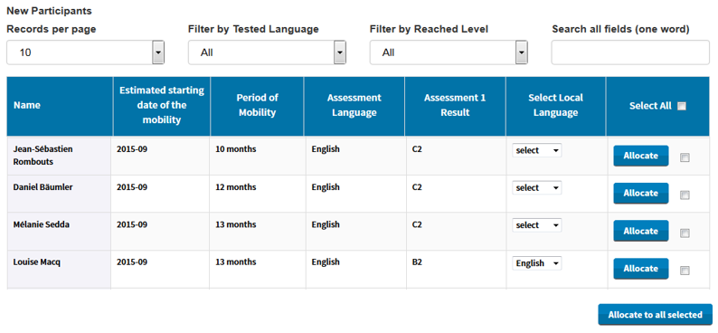

3.4 How to monitor the licences used by your participants

Once you have allocated assessment or course licences to your participants, you can monitor the use of each licence in the Erasmus+ OLS back-end.
To access the Licence Usage per Participant section, from your Home screen, click on the 4th tab (Licence Usage per Participant).
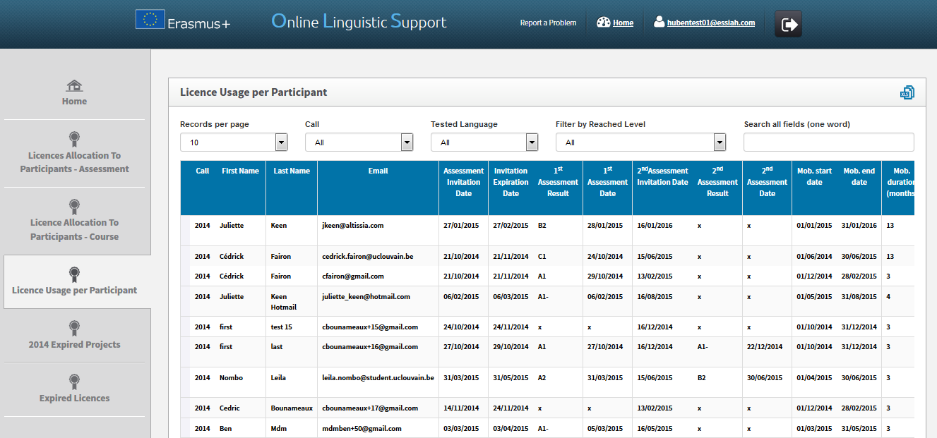
You are now accessing the Licence Usage per Participant page.

On your screen, for each of your participants you can see the following information:
- “Resend invitation” / “Cancel” buttons
- Call
- First Name
- Last Name
- Email
- Assessment Invitation Date
- Invitation Expiration Date
- 1st Assessment Result
- 1st Assessment Date
- 2nd Assessment Invitation Date
- 2nd Assessment Result
- 2nd Assessment Date
- Mobility Start Date
- Mobility End Date
- Mobility Duration (months)
- Mobility Language
- Course Licence
- Local Language
- Course Licence Allocation Date
- First Connection to Courses
- Time Spent on the Platform, i.e. total time spent by participants studying on the platform.
You can also sort the information by alphabetical, chronological or numerical order by clicking on a column title.

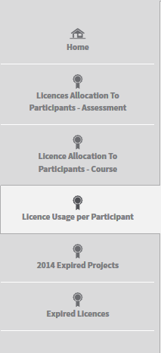
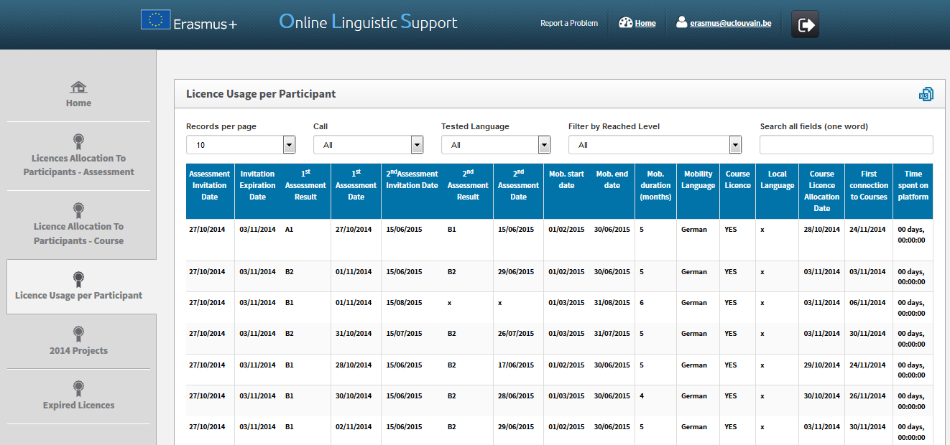

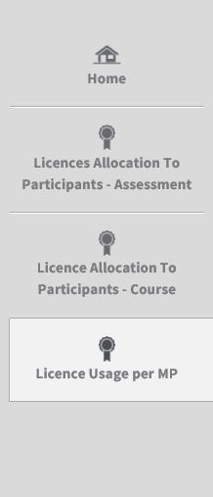
On your screen several functions are available:
- : by clicking on this button you can export all information on Participant(s) in an Excel file;
- Records per page scroll-down menu: by clicking on this button you can change the number of participants’ records that are shown per page;
- Filter by Call scroll-down menu: by clicking on this button you can filter the projects by Call (All, 2014 or 2015);
- Filter by Tested Language scroll-down menu: by clicking on this button you can filter the displayed entries, based on the tested language;
- Filter by Reached Level scroll-down menu: by clicking on this button you can filter the displayed entries, based on the level achieved in the first assessment;
- Search all fields field: by using this field you can search participants by any data (one word only);
- Previous and Next buttons: by clicking on those buttons you can navigate in the different pages of the Licence Usage per Participant table.

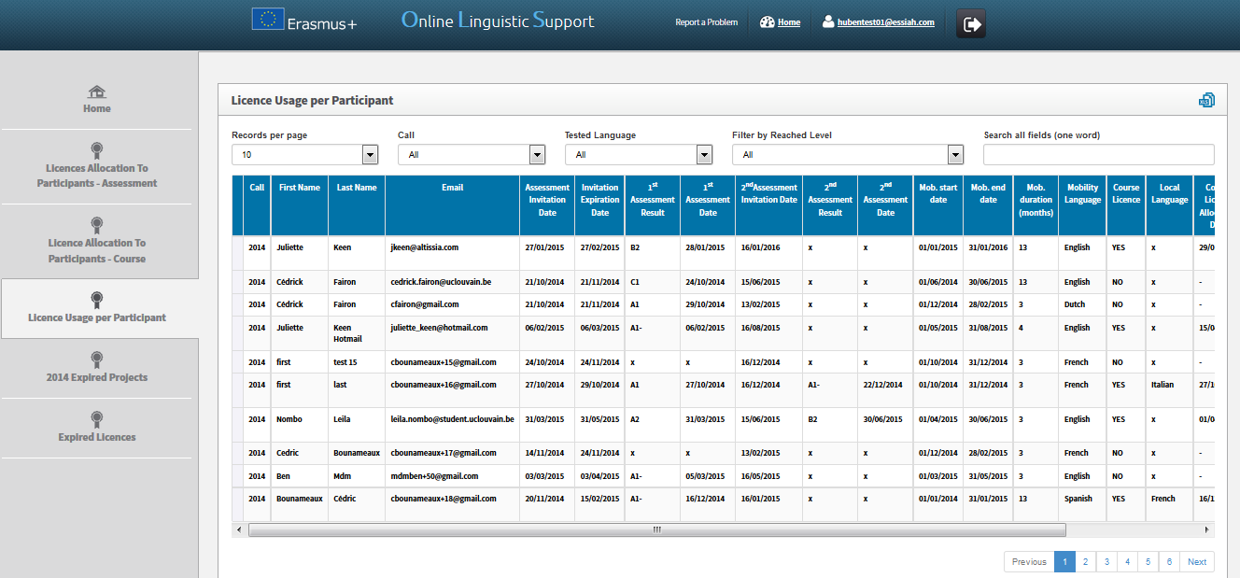

3.4.1 How to resend an assessment invitation to a participant

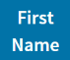
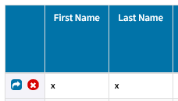
If you wish to resend an assessment invitation to a participant, click on the “Resend invitation” button (blue button) in the first column.

Note that this is only possible if the participant hasn’t started the test yet (if the participant has already started the test, the “Resend invitation” button won’t be visible).
When clicking on the “Resend invitation” button, a pop-up message appears asking you to specify a new deadline to take the test.
The participant will receive another invitation with the new deadline to take the test.
By default, the language to be tested remains the same as the one specified in the first invitation. If you wish to modify this language, you will have to delete the participant and then re-invite her/him to take the test in the new language in the Licence Allocation to Participants – Assessment screen (3.1.).
A pop-up message then confirms the invitation has been successfully resent to the participant.

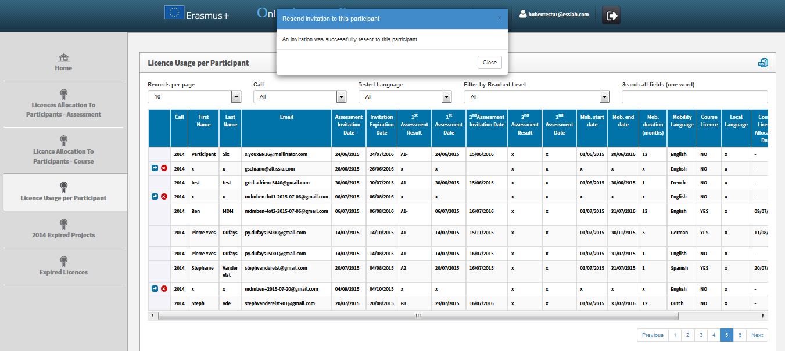

3.4.2 How to delete an assessment invitation sent to a participant

If you wish to delete an assessment invitation sent to a participant, click on the red button in the first column.
Note that this is only possible if the participant hasn’t started the test yet.

A pop-up message appears asking you to confirm that you really want to delete the invitation.
Beware that no automated notification is sent to the participant explaining that her/his invitation has been deleted.

A pop-up message then confirms the invitation has been successfully deleted.

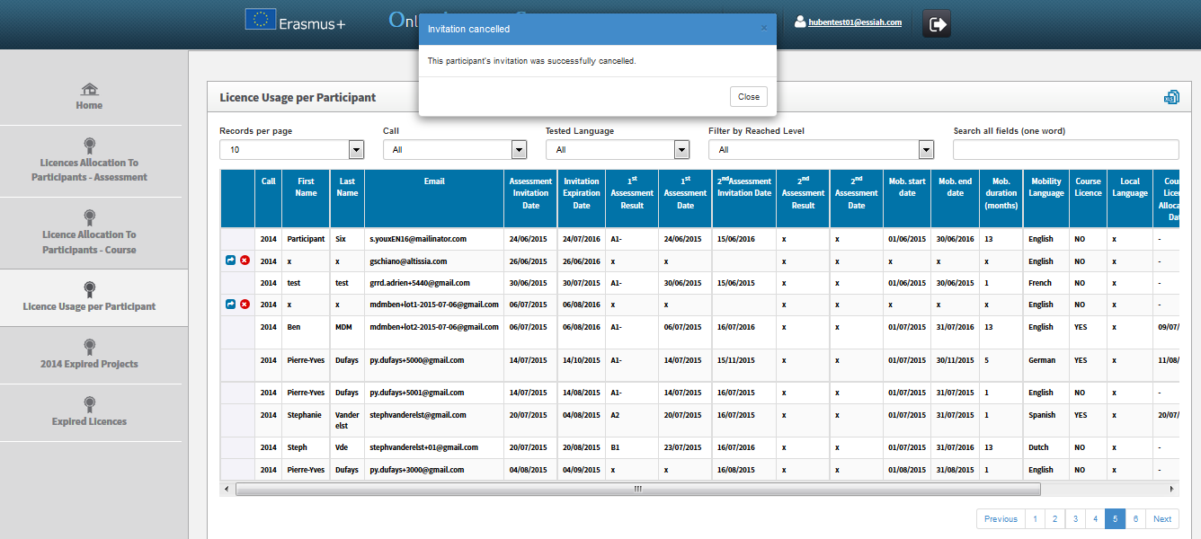

3.5 How to monitor the expired projects

In version 6, a new tab entitled Expired 2014 Projects was added to facilitate the monitoring of projects and mobility participants. This allows your current projects (Call 2015 projects) to be kept separate from expired projects (Call 2014 projects).
When projects have expired (reached their contractual end date), their content is moved to this new screen.
For projects that have expired, it is no longer possible to invite mobility participants to take the 1st language assessment. However, mobility participants that have been invited to take the 1st language assessment before the project end date are still able to take the 1st and 2nd language assessment, and you are also able to invite them to follow a language course (in the Licence Allocation to Participants – Course screen under the tab of your 2014 project – see point 3.3).

To access the Expired Projects section from your Home screen, click on the 5th tab (“Expired 2014 Projects”).

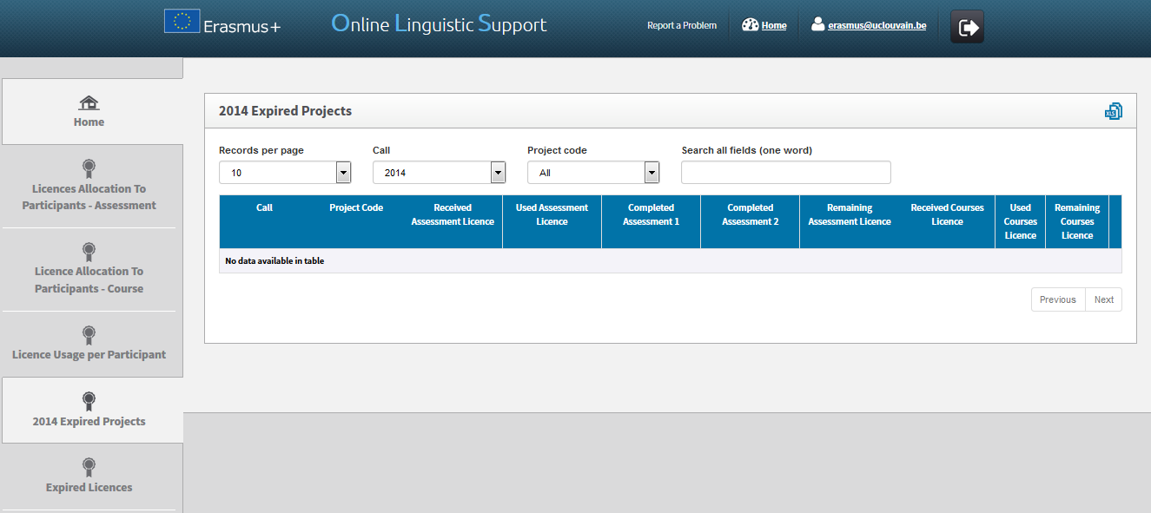
You are now accessing the Expired 2014 Projects page.
You can access the following information for each participant, on your screen:
- Call
- Project Code
- Received Assessment Licence
- Used Assessment Licence
- Completed Assessment 1
- Completed Assessment 2
- Remaining Assessment Licences
- Received Course Licences
- Used Course Licences
- Remaining Course Licences

You can also sort the information by alphabetical, chronological or numerical order by clicking on a column title.

A button labelled “Details” is situated on the far right of the project row.
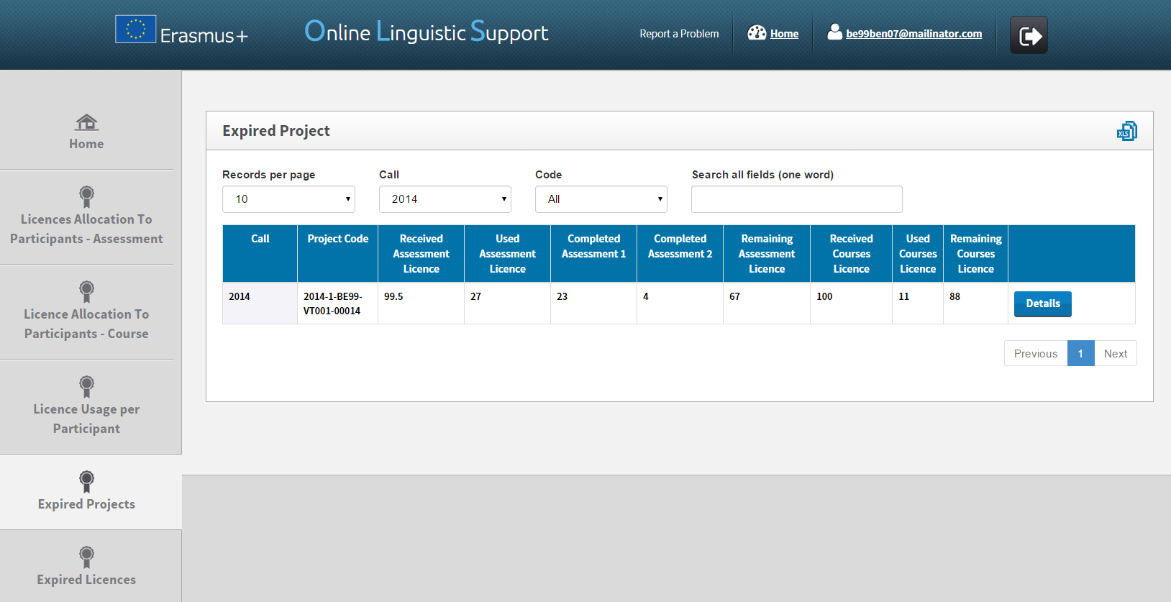

When you click on the “Details” button, you are redirected to a page showing the participant’s data for this specific project. It is the same information that you can find on the 4th tab “Licence Usage per Participant”, without the resend function (since the project has expired, you can no longer invite mobility participants to take the 1st language assessment).
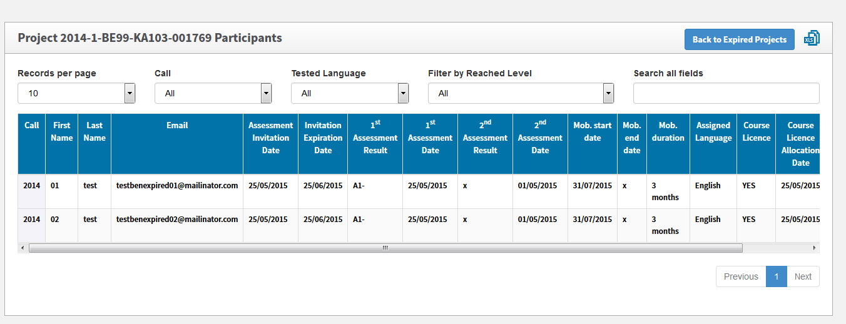
Several functions are available on your screen:
- : by clicking on this button, all information on Project(s) can be exported to an Excel file;
- Records per page scroll-down menu: by clicking on this button you can change the number of projects’ records that are shown per page;
- Filter by Call scroll-down menu: by clicking on this button you can filter the projects by Call (All, 2014, 2015, etc.);
- Filter by Tested Language scroll-down menu: by clicking on this button you can filter the displayed entries, based on the tested language;
- Filter by Reached Level scroll-down menu: by clicking on this button you can filter the displayed entries, based on the level achieved in the first assessment;
- Search all fields field: by using this field you can search with any data (one word only);
- Previous and Next buttons: by clicking on these buttons you can navigate across the different pages of the table.

3.6 How to monitor the expired licences

With version 6, a new tab entitled Expired Licences was added to facilitate the monitoring of mobility participants who have missed the deadline to take the 1st language assessment or the deadline to start following the language course. From this tab you can also re-invite these mobility participants to the 1st language assessment or the language course.
When a participant receives an invitation to take the assessment, he/she has to take it within the deadline, as specified when the invitation was sent (see point 3.1 for all details about assessment allocation to participants). If this licence is unused (participant has never accessed the 1st language assessment) it is considered to be expired. Expired licences are returned to your institution/organisation.
Note: Participants whose language assessment or course licence is still active (deadline not reached yet) are not shown in this screen. Equally, participants who started the 1st assessment without completing it are not shown in this screen (licence is lost). These participants are shown in the screen Licence Usage per Participant.
The expired licences can be found in the Erasmus+ OLS back-end Expired Licences screen.
To access the Expired Licences section from your Home screen, click on the 6th tab (Expired Licences).

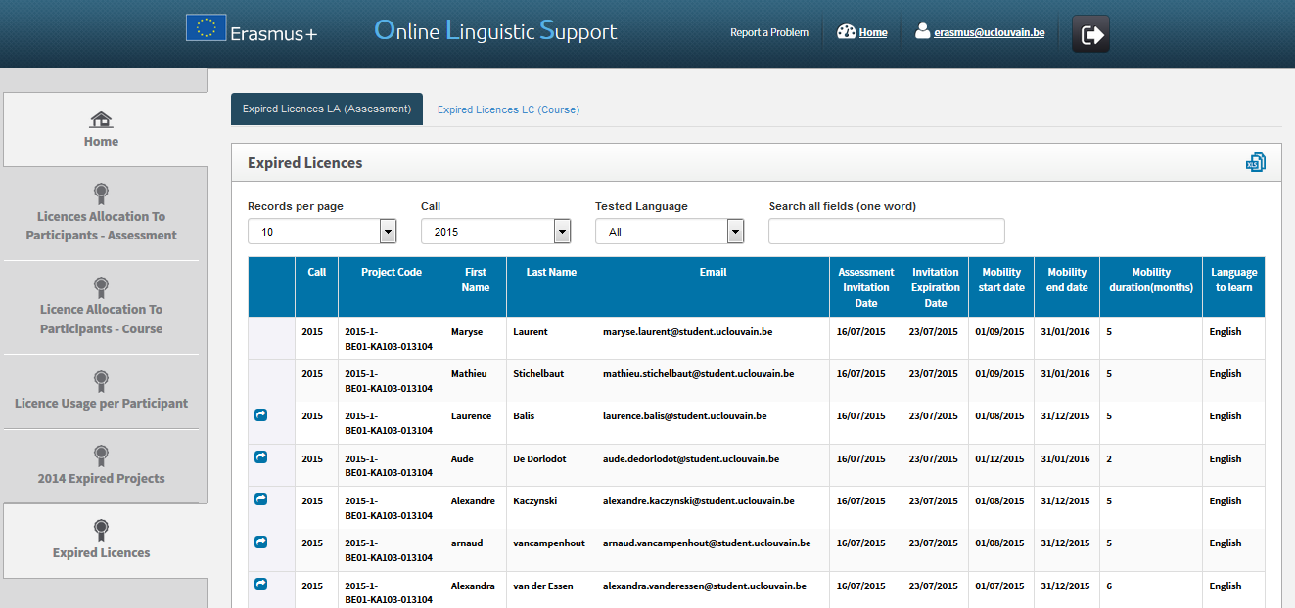

You are now accessing the Expired Licences page.

By navigating through the tabs on the top of the page, you can access the “Expired Licences LA (Assessment)” (open by default) and the “Expired Licences LC (Course)” related to each of your projects.
The two tabs show the list of participants with expired licences for language assessments or language courses. These licences have been returned to your institution/organisation.
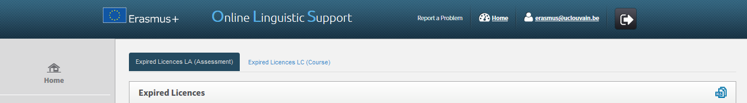

On your screen, for each of your participants you can see the following information:
- “Reallocate Invitation” button (only for language assessment)
- Call
- Project Code
- First Name
- Last Name
- Email
- Assessment Invitation Date
- Invitation Expiration Date
- Mobility Start Date
- Mobility End Date
- Mobility Duration (months)
- Language to Learn
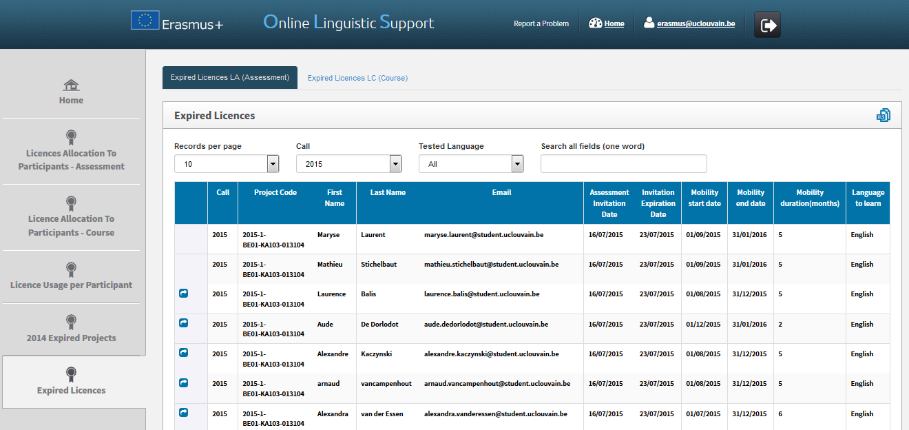
You can also sort the information by clicking on a column title.

Several functions are available on your screen:
- : by clicking on this button , all information on Licence(s) can be exported in an Excel file;
- Records per page scroll-down menu: by clicking on this button you can change the number of participants’ records that are shown per page;
- Filter by Call scroll-down menu: by clicking on this button you can filter the data by Call (All, 2014, 2015, etc.);
- Filter by Tested Language scroll-down menu: by clicking on this button you can filter the participants by tested language (All, English, French, etc.);
- Search all fields field: by using this field you can make a search with any data (one word only);
- Previous and Next buttons: by clicking on those buttons you can navigate across the different pages of the Expired Licences table.
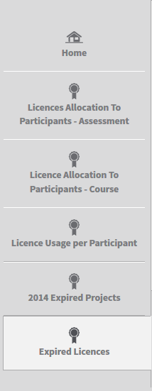

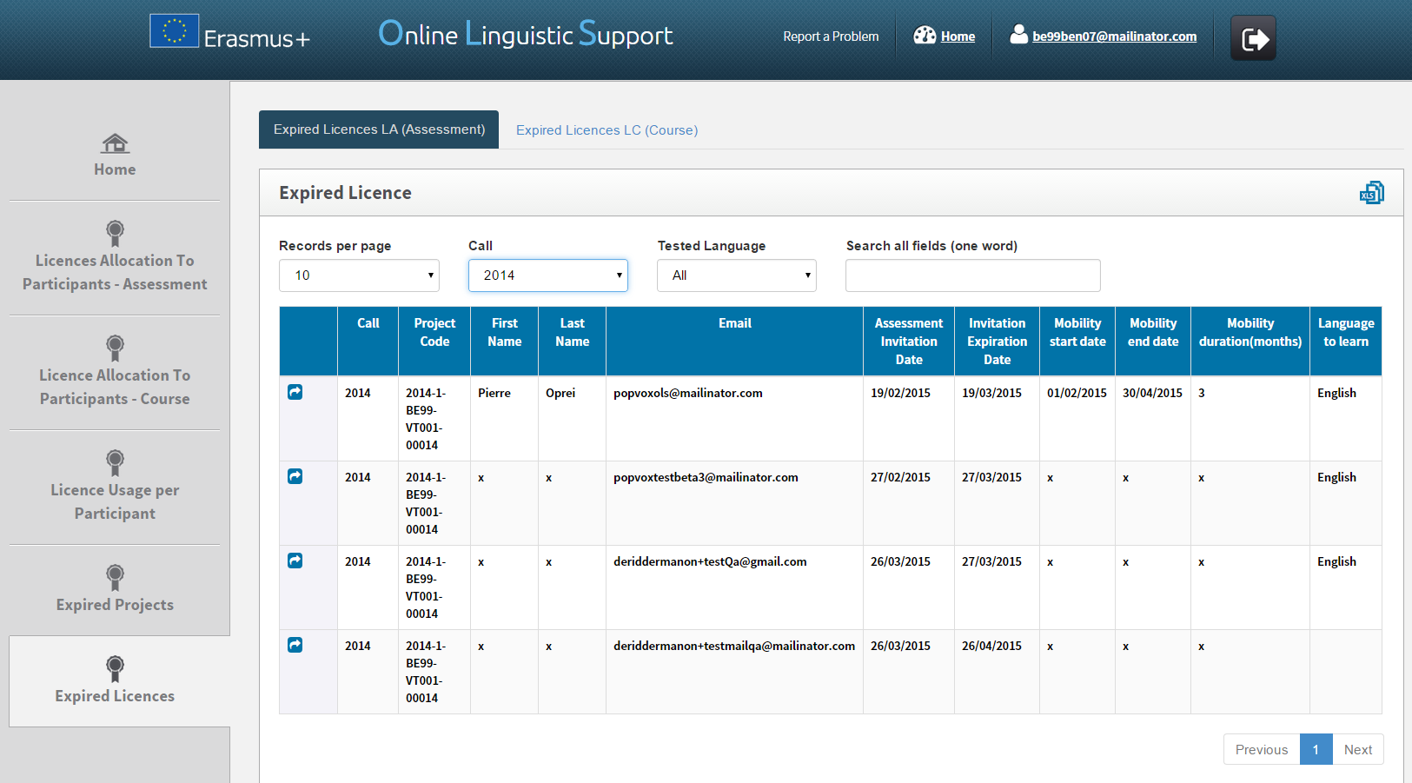
3.6.1 How to reallocate a language assessment to a participant whose licence has expired

The participants listed in this tab have missed the deadline to access the 1st language assessment and have never accessed the 1st language assessment. Therefore, the licence has expired and has been returned to you.
If you wish to resend an invitation for the language assessment to a participant, click on “Reallocate Invitation” (blue button) in the first column.
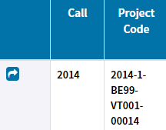

Note that when resending an invitation for the language assessment, a pop-up message appears asking you to specify a new deadline to take the test.
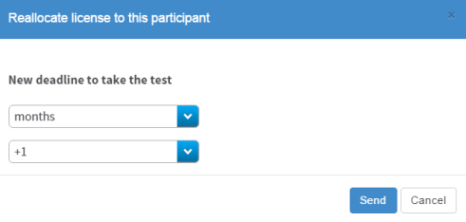

A pop-up message then confirms the invitation has been successfully resent to the participant.
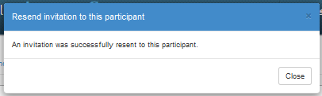

Please note:

- Participants, who have started but not completed the 1st assessment within the specified deadline, are not shown in this screen. Their assessment licence is lost and these participants can only be re-invited using a new licence and a new email address (see point 3.1).

- The “reallocate” feature from the Expired Licences page is a shortcut to redistribute a new licence to a selected mobility participant with the same language to test and from the same project. This Expired Licences page does not allow you to change the language of an invitation. If you wish to change the language of an invitation use the “Licence Allocation to Participants – Assessment” tab and select the appropriate language to test (see 3.1.).

- A participant who has been invited several times (following the expiration of its previous invitations) is listed several times. Each row corresponds to an expired invitation.

Resending an invitation from this screen has several consequences:
- A new email invitation to take the language assessment is sent to the participant
- A new licence is being used and your stock of licences decreases in number.
- If there are no available licences left in that project, a warning message will appear.

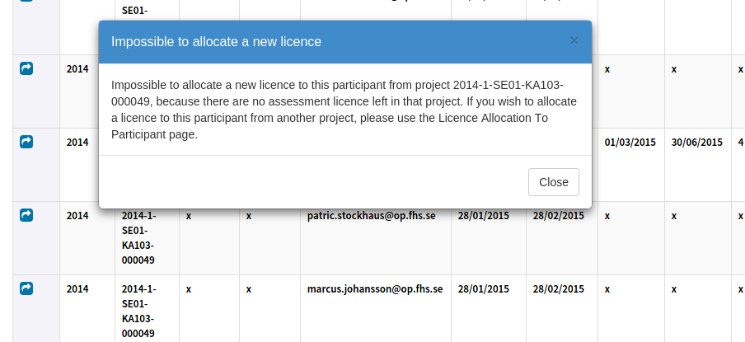

- The participant reappears on the "Licence Usage per Participant" page.
- The “Reallocate” button on the "Expired Licences" page disappears. If you want to re-invite the participant, there are two possibilities:
  - If the participant’s new licence has not expired yet: resend the invitation via the "Licence Usage per Participant" tab;
  - If the participant’s new licence has expired: this participant appears on the "Expired Licences" page.

3.6.2 How to reallocate a language course to a participant whose licence has expired

First, click on the tab “Expired Licences LC (Course)”.
If you wish to resend a language course invitation to a participant, click on “Reallocate Invitation” (blue button) in the first column.

A pop-up message then confirms the invitation has been successfully resent to the participant.
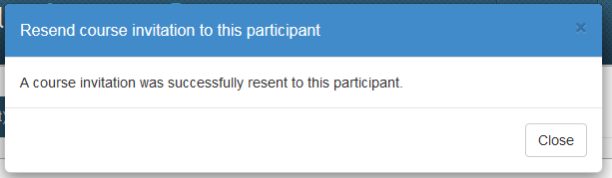

Note: The “reallocate” feature from the Expired Licences page is a shortcut to redistribute a new licence to a selected mobility participant with the same language to test and from the same project. This "Expired Licences" page does not allow you to change the language of an invitation.

3.7 How to edit your profile and create additional users

If you need to edit your profile or create additional user aliases, click on the "Profile" button in the upper right corner of your screen.

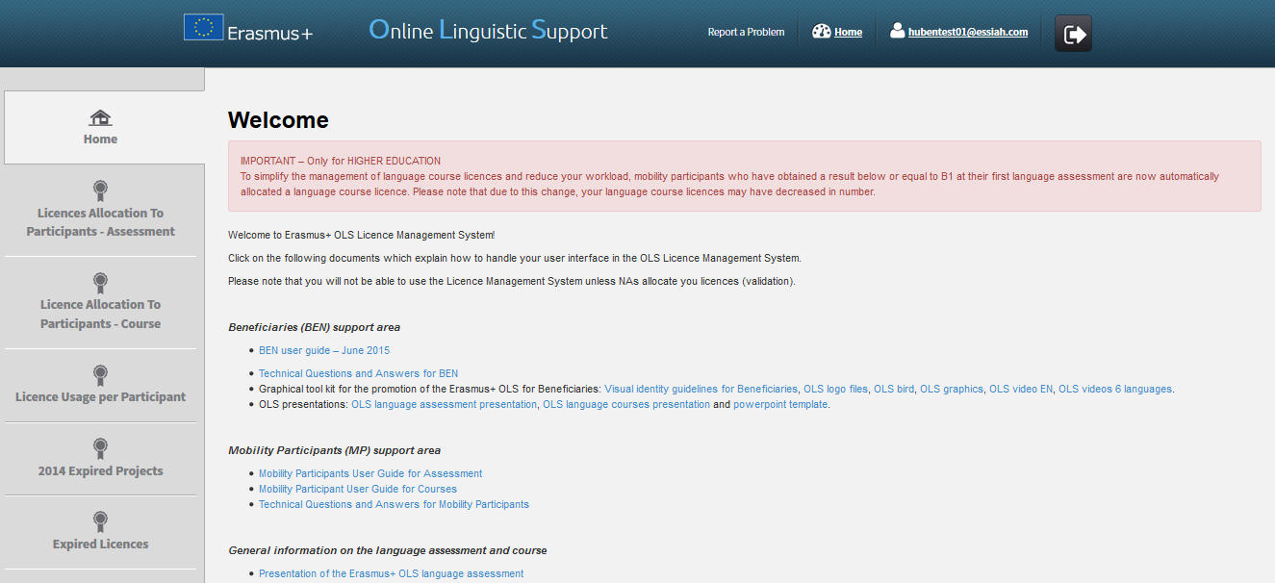

The profile page is divided into 4 parts:
- BEN information: includes your BEN PIC, BEN Name and Country. You cannot modify this information.
- Change BEN User information: allows you to edit your profile information except the login.
- Creation of additional users: allows you to create additional users (called aliases) with the same access rights as your current BEN user account.
- Additional Email for receiving notifications: allows you to add email addresses.
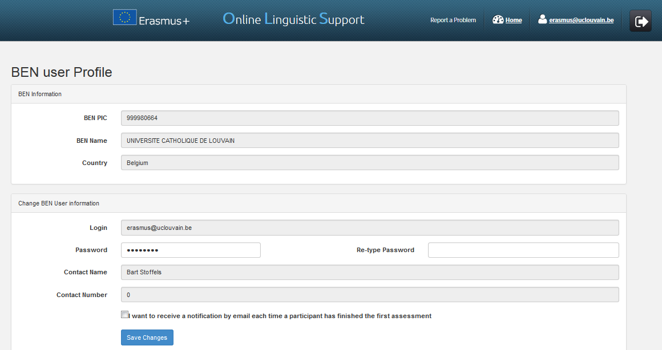
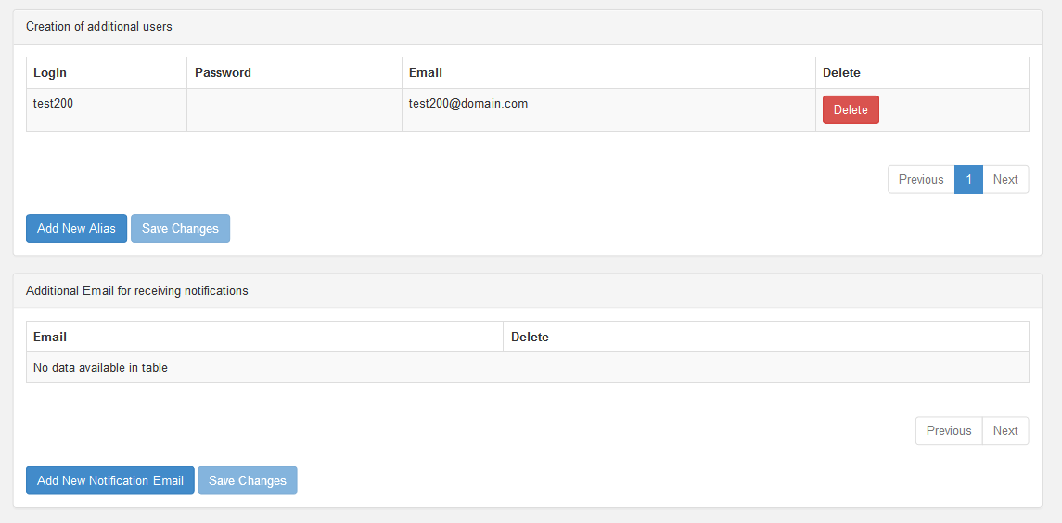

3.7.1 How to edit your profile

In section “Change BEN User information”, you can edit your password. The contact name and contact number are not editable as they are automatically imported from EPlusLink. Once you have made the necessary changes, click on Save Changes, on the lower left part of the section. A message then appears to confirm that changes have been successfully saved.

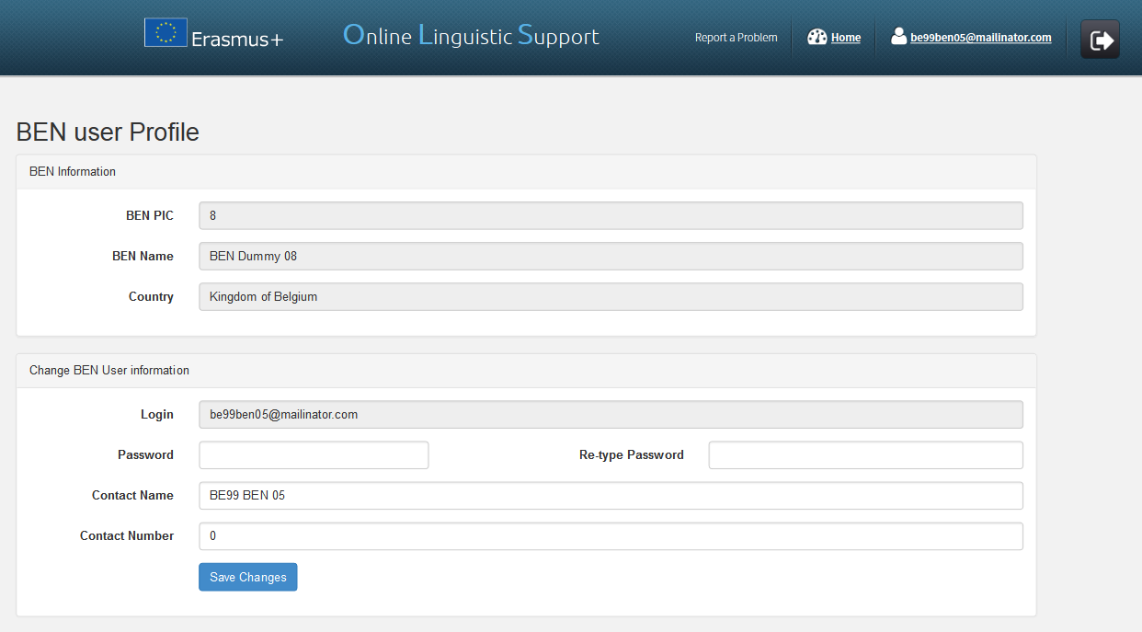

3.7.2 How to receive a notification each time a mobility participant has completed the 1st language assessment

Should you wish to receive an email notification each time a mobility participant has completed the 1st language assessment, you can tick the box "I want to receive a notification by email each time a participant has finished the first assessment". Once you have made the necessary changes, click on Save Changes, on the lower left-hand side of the section. A message then appears to confirm that the changes have been successfully saved.
If you tick this box, you will receive an email notification whenever a participant has completed the first language assessment. These notifications are not sent instantly, but once every hour.
Please note, this notification is sent to the main email address, as well as to any aliases and additional email addresses linked to the profile.
When participants don’t take the assessment within the deadline, their access to OLS is deactivated and the licence automatically returns to the remaining assessment licences tab.
This functionality can be very useful if you are a VET or Youth Beneficiary and you want to be notified on completed 1st language assessments so that you can invite your mobility participants for the language course (no automatic language course allocation as for Higher Education Institutions).

3.7.3 How to create additional users (aliases)

It is possible to create additional users to facilitate and share the work of the OLS among members of the same Beneficiary.
An alias only has access to the project(s) of the OLS contact person, to whom it is the alias of, benefitting from the same rights and functionalities as that person.
Please note that in the OLS system email addresses are used to identify an OLS user according to four specific roles: NA, NA alias, BEN, BEN alias, and mobility participant. Every person – thus every email address – can only have one role. Therefore aliases cannot be created for email addresses already in use as BEN contacts for 2014 or 2015 projects.
In the third part of your profile page, click on Add New Alias to start creating an additional user for your BEN with the exact same access rights.

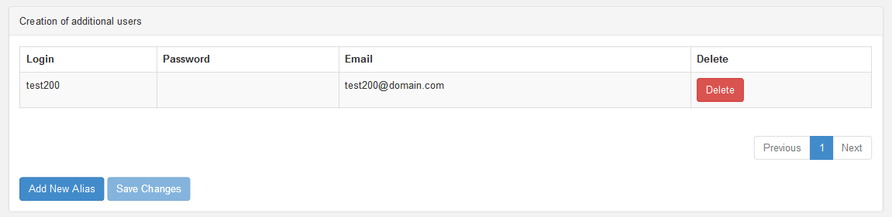

In the newly created line of the table, choose the credentials of the new BEN user account. Enter a login (may be different from the email address), a password and an email address.
Once you have entered the required data, click on Save Changes, on the lower left part of the page. The newly created user then appears on screen. To edit the new user credentials after creation, click on the fields you want to edit, change the field information and click on Save Changes.
Credentials are automatically sent to the newly created user.

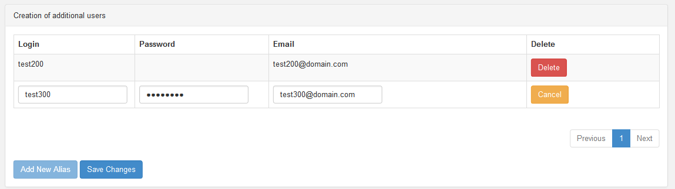

3.7.4 How to delete additional users (aliases)

In the third part of your profile page, click on the Delete button next to the alias user you would like to delete. The alias user then disappears from the list of additional users.
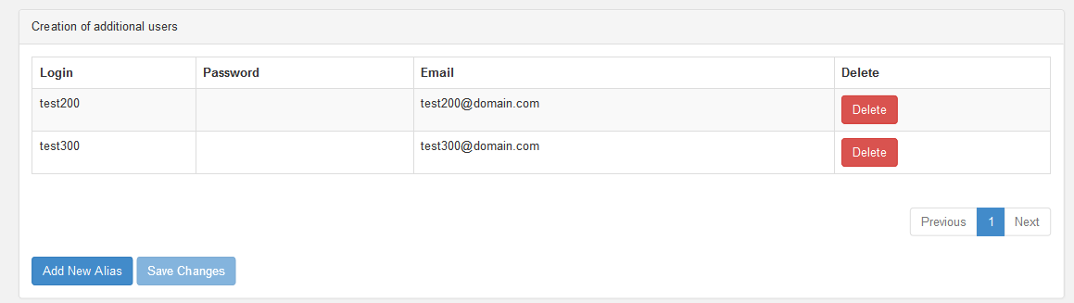

3.7.5 How to add or delete additional email addresses for future notifications

In the fourth part of your profile page, click on Add New Notification Email to add an additional email address for future notifications. These notifications include, among others, the notification on project validation by the NA and the notification on completed 1st assessments (see point 3.7.XX).
In the newly created line of the table, enter the additional email address.
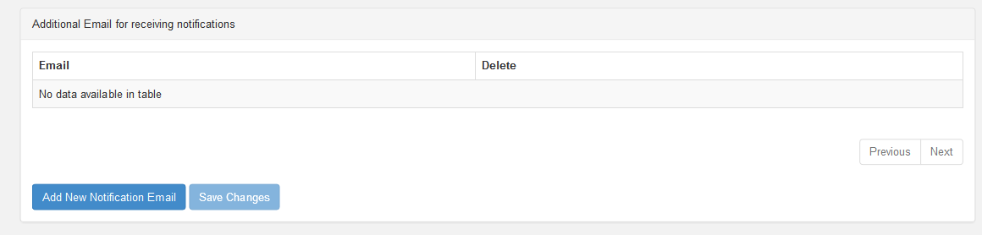

Once you have entered the required data, click on Save Changes, on the lower left part of the page. The added email address then appears on screen. To edit the address, click on it, enter the corrected email address and click on Save Changes.
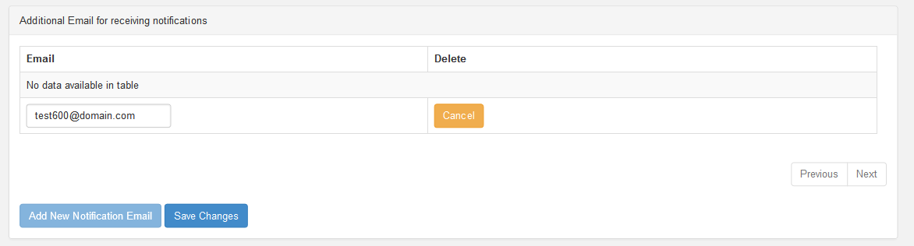

Click on the Delete button next to the email address you would like to delete. The email address then disappears from the list of notified email addresses.

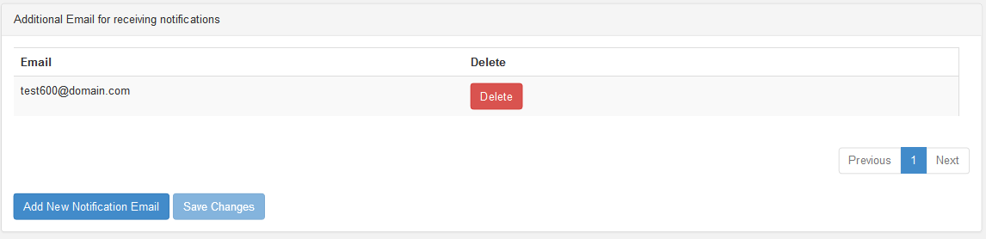

To return from your profile to the Homepage of the Licence Management System, click on the Home button.

4. Helpdesk

If you encounter any problem or issue when following the instructions above, please contact the Helpdesk by clicking on the Report a Problem button in the header.

